【例4-59】计算二维频率响应
Hd = zeros(16,16);
Hd(5:12,5:12) = 1;
Hd(7:10,7:10) = 0;
h = fwind1(Hd,bartlett(16));
colormap(jet(64))
freqz2(h,[32 32]); axis ([–1 1 –1 1 0 1])
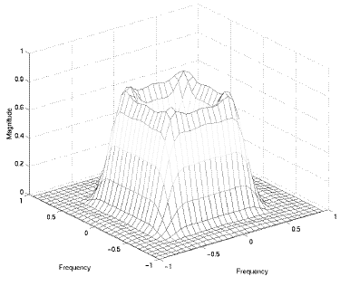
二维频率响应的就算

